The effects of mangrove restoration on fish stocks and marine biodiversity in Indonesia

SOPHIE WULFING1, DR. ROHANI AMBO RAPPE2

1Fulbright Research Grant

2University of Hasanuddin, Department of Marine Science

**Research Objectives**

1. Determine the effect of mangrove restoration on the fishery production on Pulau Tanakeke, Takalar Regency, South Sulawesi Province, Indonesia.
2. Uncover what aspects of mangrove cover is most beneficial to juvenile fish populations (i.e. reductions in water temperature, shade, or increased plant biomass).
3. Disseminate these findings to the local community on Tanakeke with the help of the NGO Blue Forest as part of their community engagement program as well as help Blue Forests demonstrate the value of their efforts to potential funding sources and publish findings to international scientific journals.

**Background**

Despite all of their contributions to ecosystem health, mangrove environments are being threatened worldwide. As the largest archipelagic country, Indonesia’s mangroves’ contribution to flood protection and extreme weather mitigation is vital to the health and safety of many of its inhabitants. As a response to habitat loss, the Indonesian government has committed to restoring 600,000 hectares of mangroves in the country in 2024, the most ambitious mangrove restoration project in the world. Tanakeke Island in South Sulawesi, is one location where this restoration effort is taking place. 1,200 hectares of mangroves were converted into aquaculture ponds in the 1980s and 1990s due to timber production and shrimp aquaculture, which is about 70% of its historical cover (Blue Forests 2012; Brown et al., n.d.). In response to mangrove restoration conducted by the Non-Governmental Organization Blue Forests, the community has seen great success in both engagement and successful mangrove rehabilitation, where hundreds of community members have participated since the 1990’s (Blue Forests 2012; “Past and Present on Tanakeke Island” 2013).

Further, small scale fishing is an essential part of peoples’ livelihoods on Tanakeke. Locally caught seafood is the main source of protein on this island (Blue Forests 2012). Mangroves provide refuge for about 55% fish catch biomass in Indonesia (World Bank 2022). Fisher income has been shown to be negatively affected by mangrove habitat loss, and because of this, the financial gain of mangrove restoration is predicted to be more lucrative than any alternative land use such as aquaculture (Yamamoto 2023). While these mangrove restoration efforts have resulted in increased flood prevention and ecotourism, little research has been done to assess the improvements in marine biodiversity and benefits to fish stocks. In this project, we aim to understand how this restoration is affecting local marine biodiversity and the sustainability of commercially fished species on Tanakeke Island. We will use Unbaited Remote Underwater Video (URUV) methods to assess the marine biodiversity of mangrove habitats and compare them to the biodiversity of areas that have not undergone mangrove rehabilitation. Further, we will collect temperature and light data to create a statistical analysis of which variable is the most important when fostering biodiversity in mangroves.

**Methods**

## 

## Budget:

|  |  |  |  |  |  |  |
| --- | --- | --- | --- | --- | --- | --- |
| **Item** | **Purpose** | **Model No.** | **Cost/Unit (GBP)** | **No. Units** | **Total Cost (GBP)** | **Notes** |
| Hard Drive | Raw Data Storage | Toshiba Canvio Basics 2TB Portable External Hard Drive | 48.5109 | 1 | 48.5109 |  |
| GoPros | Video Data Collection | SJCAM SJ4000 Action Camera | 34.8219 | 8 | 278.5752 | 6 Cameras needed, two backups |
| MicroSD to USB adapter | Data Download | SD Card Reader | 9.7119 | 1 | 9.7119 |  |
| Light/Temp Loggers | Light/Temp Data Collection | HOBO Pendant MX Temperature/Light Data Logger | 76.95 | 4 | 307.8 | Will be recording year-round |
| Car Rental | Car to Boat |  | 57.915 | 8 | 463.32 | 8 Excursions between Feb and Sept 2024 |
| Regular Boat | Trips to Island |  | 1.5795 | 16 | 25.272 | 8 Excursions between Feb and Sept 2024 |
| Small Boat | Trips around Island |  | 15.795 | 24 | 379.08 | 8 Excursions * 3 Days/Excursion |
| **Item** | **Purpose** | **Model No.** | **Cost/Unit (GBP)** | **No. Units** | **Total Cost (GBP)** | **Notes** |
| Accommodation (community housing) |  |  | 5.265 | 24 | 126.36 | 8 Excursions * 3 Days/Excursion |
| Research Assistant Stipend |  |  | 7.8975 | 24 | 189.54 | 8 Excursions * 3 Days/Excursion. Assuming 1 Research Assistant |

## Total Cost: £1,828.17

## Data Collection:

In this project, we plan on selecting three different sites across the island. Within each site, we will locate a recently restored mangrove, mangroves that were restored over ten years ago, and an area where mangroves have not been rehabilitated yet. Recently restored mangrove sites will be in Lantangpeo, where Blue Forests is currently working on mangrove rehabilitation (Figure 1). Sites that have been restored over ten years ago and unrestored sites will be located in Tompotanah and Ujungtanah (Figure 1). At each site, we will place two cameras at 1m depth facing horizontally at a 7 degree angle from one another in order to measure fish length and water visibility. Next to the cameras, we will place the light and temperature loggers which will collect throughout the duration of filming. With two cameras per location, this will total 18 cameras deployments per month for nine months between February 2024 and October 2024. Cameras will record for 1 hour. After which, the cameras and loggers will be extracted from the site, the recording will be downloaded, and then the cameras will be moved to the next site where we will conduct the same experiment. Sampling of each site will occur on a monthly basis.

## 

## Analysis:

We will measure biodiversity using the MaxN calculation method, as it is the most robust calculation for relative abundance (Whitmarsh, Fairweather, and Huveneers 2017). Further, we will use the data collected from the temperature and light loggers to create a statistical model of fish abundance in order to determine if fish abundance is more attributed to decreased water temperature or the shaded areas provided by mangrove habitats. Expected Result As has been found in previous literature, we expect the sites with older, more established mangroves to foster the most biodiversity of juvenile fishes due to better shelter from predators and cooler temperatures. We expect the areas with no mangrove restoration to exhibit the least amount of biodiversity due to the exposure of these environments to predators and higher temperatures.

# 

# Outputs

The outcomes of this project will be to disseminate its results to the local community. This will be done with our partnership with Blue Forests, an NGO that oversees mangrove replanting on this island and facilitates community action and engagement in this restoration project. With their help, we will incorporate the results of this study into their curriculum for educating the public on the benefits of mangroves and use these results in reports made by Blue Forests to potential funding sources. Further, at Universitas Hasanuddin, I will assist in Dr. Ambo Rappe’s lab by leading data science and coding seminars for graduate and undergraduate students at the University in order to help them learn data organization and analysis for their own projects. Finally, with the help of Dr. Ambo Rappe, we intend on publishing this research in an international journal.

**Works Cited**

Blue Forests. 2012. “Adaptive Collaborative Management Plan for Building Mangrove Resilience in Tanakeke Island.”

Brown, Ben, Gaëll Mainguy, Ratna Fadillah, Yusran Nurdin, Iona Soulsby, and Rio Ahmad. n.d. “CASE STUDY: Community Based Ecological Mangrove Rehabilitation (CBEMR) in Indonesia.”

“Past and Present on Tanakeke Island.” 2013. *Blue Forests*. <https://blue-forests.org/en/newsroom/news/past-and-present-on-tanakeke-island/>.

World Bank. 2022. “New Project Will Support Large-Scale Mangrove Conservation and Restoration in Indonesia.” Text/{HTML}. *The World Bank*. <https://www.worldbank.org/en/news/press-release/2022/06/07/new-project-will-support-large-scale-mangrove-conservation-and-restoration-in-indonesia>.

Yamamoto, Yuki. 2023. “Living Under Ecosystem Degradation: Evidence from the Mangrove–Fishery Linkage in Indonesia.” *Journal of Environmental Economics and Management* 118 (March): 102788. <https://doi.org/10.1016/j.jeem.2023.102788>.

**Figures:**

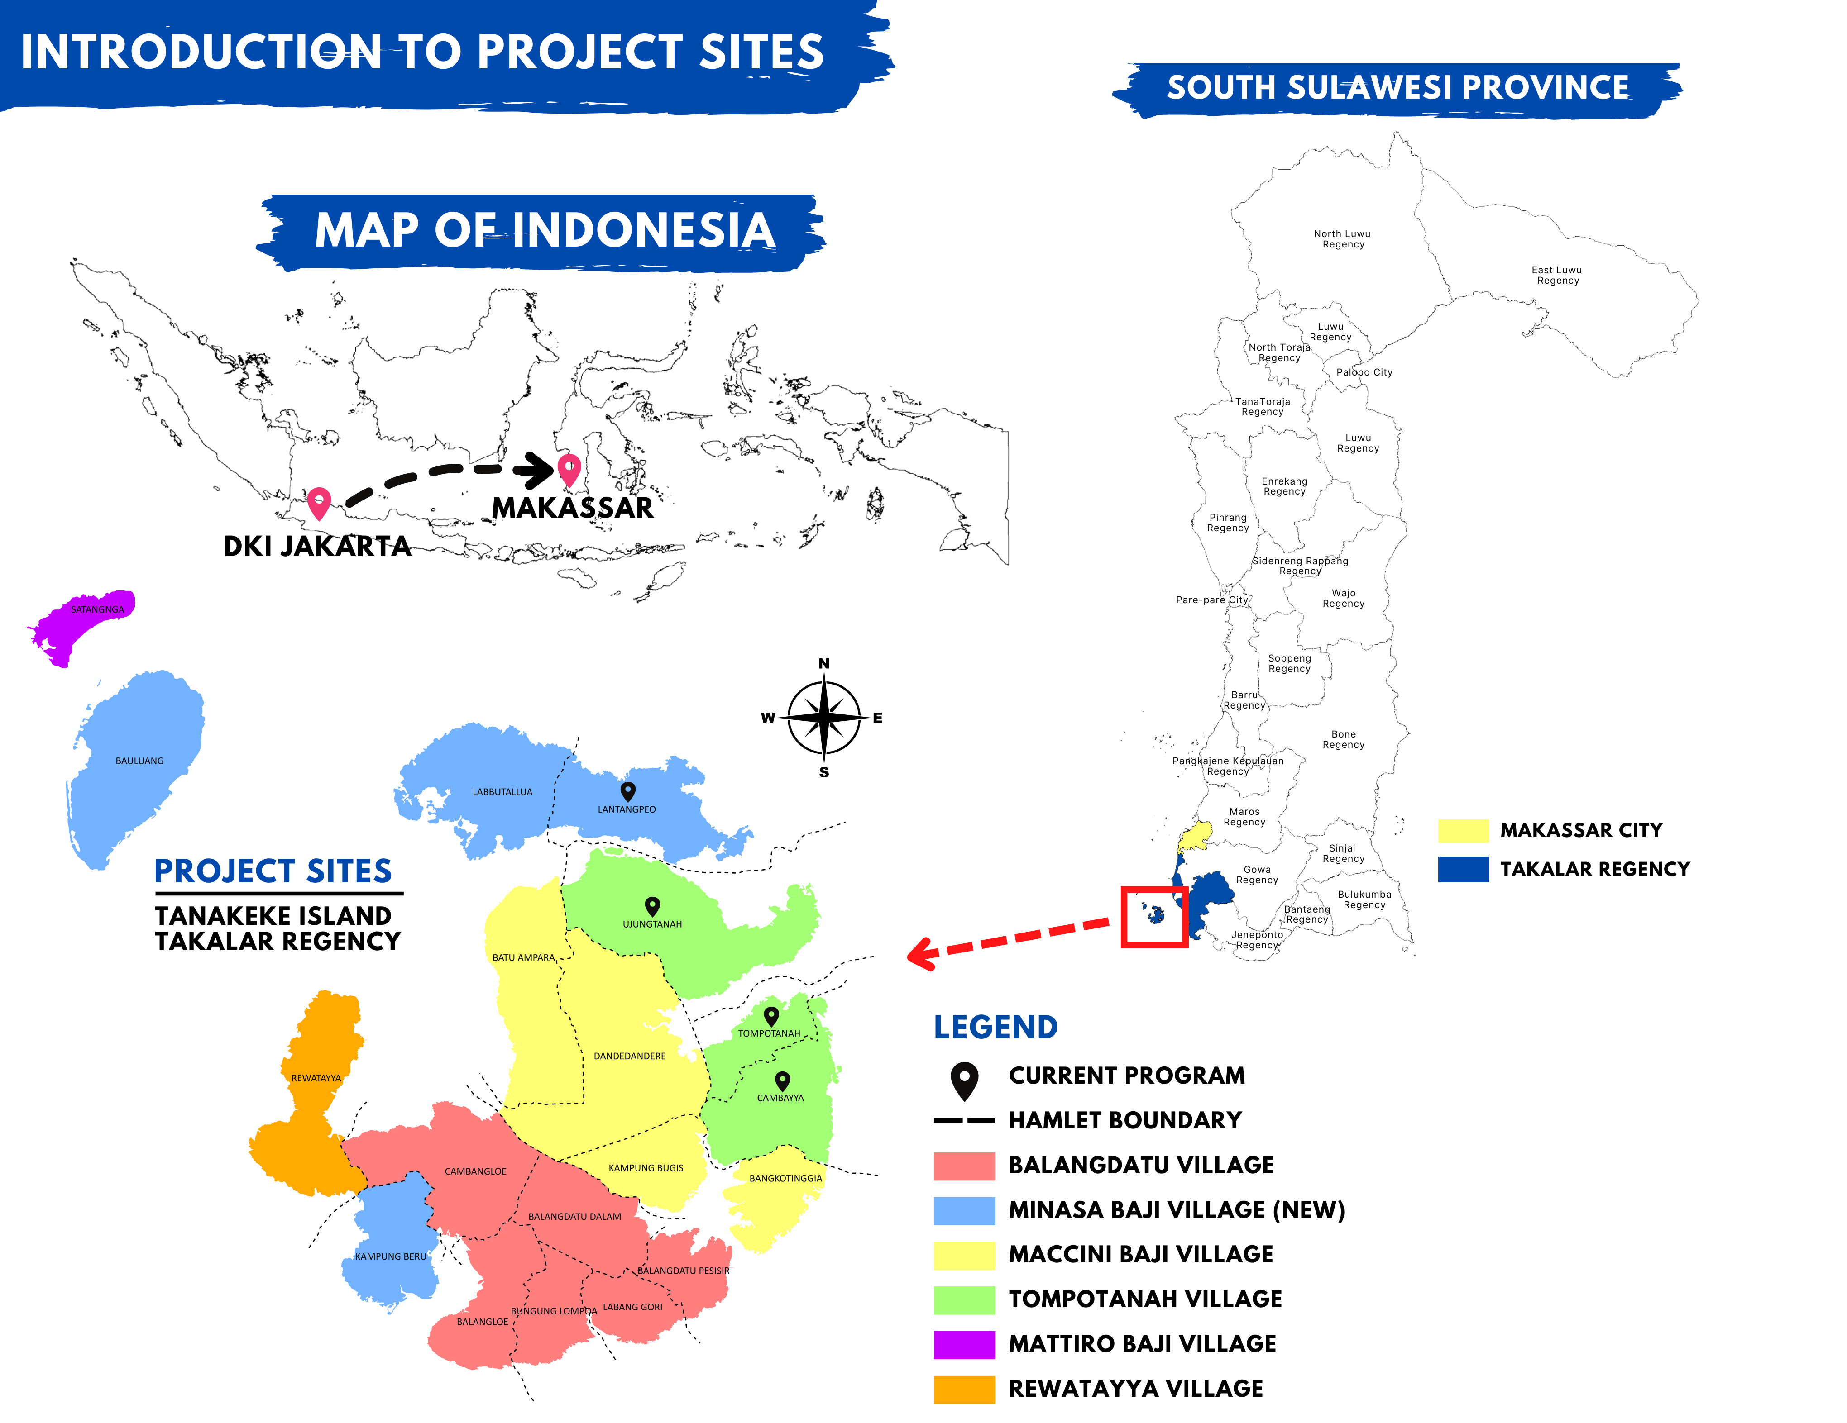

Figure 1: A map of Tanakeke Island with village (desa) names (left). The right image shows the mangrove restoration sites on Tanakeke Island by Blue forests. Both images are courtesy of Blue Forests.